Exercise Set 0 – Team L7

Purpose: Demonstrate use of the on-line course resources and ability to upload assignments back to the learning management system.

Assessment Criteria: Completion score based on successful upload to class learning management system, and correct plot result in item 4 below.

Exercises:

1. Visit the course umbrella website http://theodore-macbookpro.ttu.edu/ and screen capture the June 20, 2018 post.

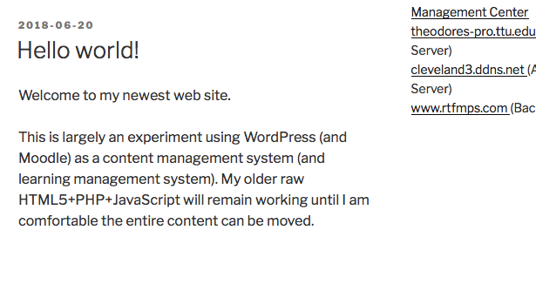

Figure 1. Screen capture of http://theodore-macbookpro.ttu.edu/

2. Take the link on the right margin index to the RTFM Learning Management Site

http://theodore-macbookpro.ttu.edu/moodle/ and screen capture the entry page.

It may issue a password challenge, in which case meet the challenge and capture an

image of the first content screen

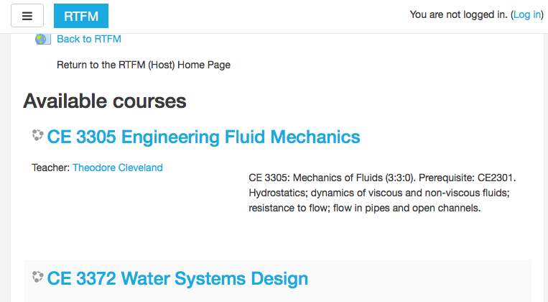

Figure 2. Screen capture of Moodle site entry screen (before attempt login).

3. Visit the on-line toolkit http://theodores-pro.ttu.edu/mytoolbox-server/ and use the toolkit (Fluid Mechanics Tools) to determine the density of water at 40-degrees

Celsius. Screen capture the toolkit output.

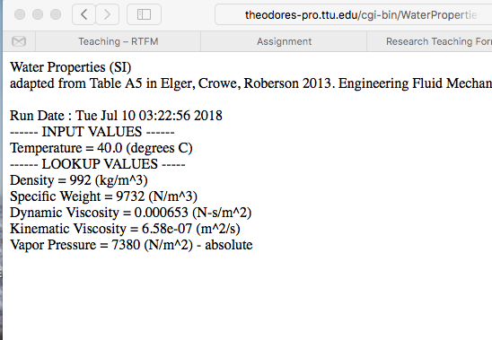

Figure 3. Screen capture of online toolkit output.

4. Download and install R onto your laptop. Generate a simple plot using the following script instructions:

x <- c(0,1,2,3,4,5)

y <- x^2

plot(x,y,type="s")

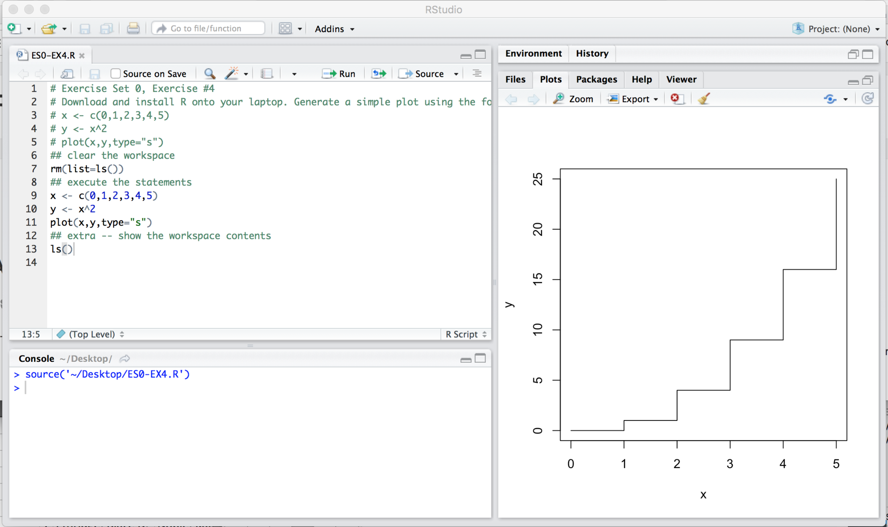

Figure . Screen capture of simple R script.